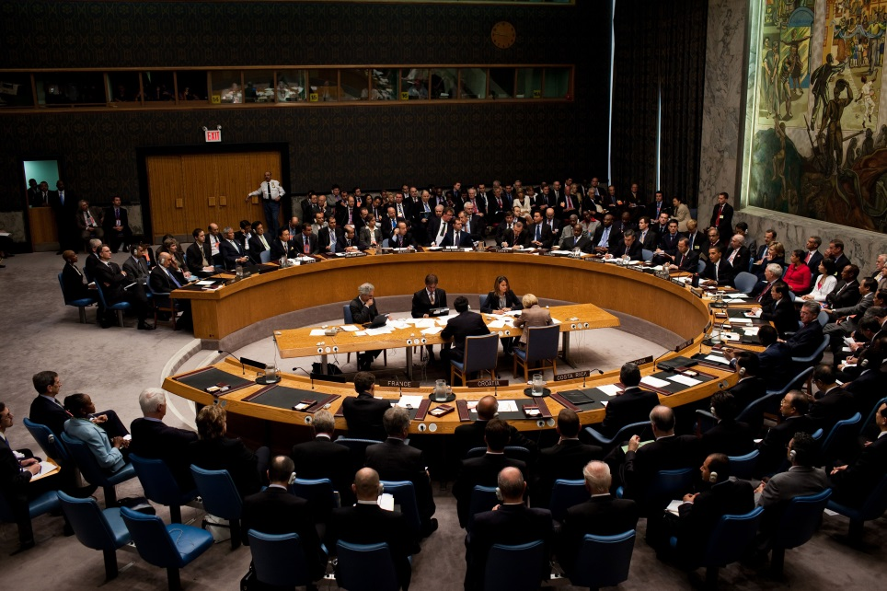

SECURITY COUNCIL

STUDY GUIDE

**Topic I : Question of the crisis in Ukraine and secessionist movements**

**Introduction**

Ukraine has quite a long path to travel before it can achieve complete stability after suffering an intense change of government, an annexation of the Crimean region, a significant portion of its territory by the Russian federation and economic contraction.

With reports of violent protests involving provocateurs and vigilantes in various parts of the country, members of the general public remain fearful for their future. There are also reports of citizens buying guns and weapons being distributed from military armories to the public and paramilitary groups. And a new national guard and local self-defense units are being organized.

The central government in Kyiv looks decidedly unlike Ukraine, lacking some key party and regional representation. The most committed revolutionaries, distrustful of the provisional government and its handling of the Crimea crisis, continue their occupation of the Maidan and threaten another uprising if they feel betrayed by the government.

There is little news from Ukraine’s powerful business elite, but with its record of dominating the country’s politics and economy, it is surely navigating behind the curtain to protect its corporate interests.

Moreover, Russia’s annexation of Crimea has raised the specter of separatism in other parts of Ukraine. In the West, where parts of the country were carved out of Hungary, Romania, Slovakia, and Poland, local residents may look to their more prosperous co-ethnics across the border where life is more stable and well-off. After the 2004 Orange Revolution it is clear that caution must be taken also considering its current prospects. Following their triumph on the Maidan and then at the polls, the new team became mired in factional rivalries and allegations of corruption. Critical reforms were never implemented, and Ukrainians, having lost confidence in the revolutionaries, elected Viktor Yanukovych as their next leader. Many members of the provisional government today bring with them the baggage of that era, and their past record does not inspire optimism about a fresh start.

**Background**

Ukraine, the largest state situated wholly within the European continent, comparable in size and population to those of France, is situated in the sensitive region between Russia and Poland, Romania, Hungary and Slovakia, all member states of North Atlantic Treaty Organisation (NATO), therefore possessing a geographically significant position.

Throughout history, the area has been heavily ruled and divided by various powerful rulers of Russian and Polish ethnicity. In fact, the Ukraine remained divided until its consolidation into a Russian republic. Following the Russian Revolution, a Ukrainian movement for self-determination emerged, which led to the creation of several separate Ukrainian states for a short period of time. By 1921, however, most of the Ukraine had been taken over by the Soviet Union and eventually the Ukraine became one of the original constituent republics of the Soviet Union in December 1922, playing a key role in the formation of the whole Soviet Union, being central to the Union geographically and also in terms of economic progress. Stalin’s agricultural collectivization, imposed in the 1930’s, ushered in a severe famine and the death of millions in the Ukraine, with any opposition being purged, the situation being similar to the rest of the states in the Soviet sphere of influence.

Near the end of the Second World War, the Germans that were first welcomed as liberators were later met with opposition from the Ukrainian guerrillas who also displayed such aggression to the Soviet forces with anti-Soviet resistance continuing until 1953. After the war Stalin forcibly deported the entire community of Muslim Tatars, a group of 200,000 - 300,000 who had lived on the Crimean peninsula for centuries, due to their alleged collaboration with Nazi Germany. Only after the collapse of the Soviet Union could many of them return to the Crimea. Several territorial changes occurred in the Ukraine during and after the Second World War. For instance, East-Galicia, including Lviv, was added to the Ukrainian territory in 1945. In 1954 Nikita Khrushchev had the Crimean region annexed to the Ukraine.

In 1986, one Ukrainian city, namely Chernobyl, gained an ambiguous reputation as one reactor in its nuclear power station exploded, sending a radioactive cloud across Europe, contaminating approximately 8% pf Ukraine’s territory.

In July 1990, the Ukrainian parliament passed a declaration of sovereignty and after a failed coup in Moscow against Mikhail Gorbachev, the Ukraine passed the act of independence and held a nationwide referendum in which 90% of the Ukrainians voted in favour of independence. Being ranked as number three nuclear country in the world, the Ukraine ratified the Strategic Arms Reduction Treaty and the Nuclear Non-proliferation Treaty and turned its nuclear arsenal over to Russia for destruction (completed 1996). After independence tensions emerged over the Crimean peninsula, former Russian territory with its majority Russian population. In 1995, after the Crimea challenged the Ukrainian government's sovereignty and threatened to secede, the Ukraine placed Crimea’s government under national control.

Another important and rather contentious issue was the division between Russia and the Ukraine of the former Soviet Black Sea fleet, based in the Crimean port of Sevastopol. A basic agreement, under which four fifths of the fleet would fall under Russian control, was reached in 1995, and in 1997 it was agreed that Russia would be allowed to base its fleet at Sevastopol for 20 years. In 2010 the agreement was

extended by another 25 years to 2042 in exchange for Russia’s supply of discounted natural gas.

The first president after independence, Leonid Kravchuk, presided over a period of economic decline and excessive inflation. His successor, Leonid Kuchma, oversaw steady economic recovery, yet only a few state-run companies dominated the market. More importantly, he was accused of conceding too much to Russian economic interests, corruption and limiting media freedom. Public opinion turned against him, especially after manipulations of presidential elections in 2004, which led to the peaceful “Orange Revolution”. A diverse alliance of pro-Western party members, socialists, nationalists and business leaders united behind the main opposition leader and former prime minister Viktor Yushchenko, who won the re-held presidential election against Viktor Yanukovych. Yuliya Tymoshenko.

The new president starts course that should bring Ukraine closer to the EU and NATO. Due to an open rivalry and the president dismissed the government of Tymoshenko in 2005. In 2006 Yanukovych became Prime Minister again until parliamentary elections in 2007. After those elections Yulia Tymoshenko was appointed prime minister again, in coalition with President Yushchenko’s party.

Event though the EU has become the most important trading partner over the past few years, Russia remains the largest individual trading partner and the Ukraine still greatly depends on Russia for its gas supply.

Ukraine is a major transit route for Russian gas export to Europe. In January 2006 and 2009 Russia has cut supply for gas in a dispute over unpaid bills and prices. The effects of these cuts where also felt in other European countries, where people had to deal with gas shortages.

In 2010 Viktor Yanukovych, won the presidential election and Tymoshenko resigned as a Prime Minister. Yanukovych swiftly opted for implementing a foreign and trade policy towards Russia and clamped down on media freedom. He also had various opponents, most prominently Ms Tymoshenko, charged with abuse of state funds with regards to gas deals and imprisoned in trials widely regarded as politically- motivated. The parliamentary elections of 2012 led to a major victory of Yanukovych’s party. However, OSCE observers expressed grave concerns over irregularities.

In August 2013 trade tensions with Russia flared again, with Ukraine’s trade negotiations with the European Union being the trigger. In November 2013 the Ukrainian government decided to abandon plans to sign an association agreement with the EU, which led massive anti-government protesters to take streets of Kiev, as well as an on-going political crisis.

**DEVELOPMENT OF THE CONFLICT IN UKRAINE**

**On 21 November 2013** President Yanukovych's cabinet announces that it is abandoning an agreement that would strengthen trade ties with the EU, and will instead seek closer co-operation with Russia. The trade agreement, as well as a political association deal, is part of the European Union’s “Eastern Neighbourhood Policy“, which was launched in 2005. The incentive was to offer trade and political benefits to the post-Soviet states traditionally falling within Moscow's orbit. The neighbourhood policy, however, does not offer eventual membership of the EU or negotiations to join. Ukrainian MPs also reject a bill that would have allowed jailed opposition leader Yulia Tymoshenko to leave the country.

Protests begin that same night, with only several hundred present at first. Media starts making its first comparisons with the Orange Revolution.

**On 24 November** the protests gather pace, with 100,000 people attending a demonstration in Kiev. It is the largest protest in the Ukraine since the Orange Revolution in 2004.

**On 30 November** the police launch their first raid on protesters, arresting 35 persons. Images of injured demonstrators spread quickly in the media, raising the international profile of the protests. Protesters occupy Kiev City Hall and Independence Square in dramatic style on 1 December. Subsequently they turn the square into a tent city.

**On 8 December** the largest demonstration so far comprises of 800,000 people attending a protest in Kiev. After talks with President Viktor Yanukovych, Russian President Vladimir Putin agrees on 17 December to buy $15bn of Ukrainian debt and to reduce the price of Russian gas supplies to Ukraine by about a third.

**On 16 January 2014** Ukraine’s parliament passes a restrictive anti-protest law, which opponents call “draconian”. 22 January marks the day that the unrest turns deadly for the first time as two people die from gunshot wounds after clashing with the police. The body of a high-profile activist, Yuriy Verbytsky, is found the next day in a forest after he was reportedly abducted earlier in the week. The 24 January sees the storming of regional government offices in Western Ukraine by the protestors. As pressure mounts, Ukraine's Prime Minister Mykola Azarov resigns and parliament annuls the anti-protest law on 28 January. One day later, the Parliament passes an amnesty bill promising to drop charges against all those arrested during the unrest, if protesters leave government buildings. The opposition rejects its conditions.

On 14 February all 234 protesters, who have been arrested since December, are released but charges against them remain. On 16 February, protesters evacuate Kiev city hall after occupying the building since 1 December, along with other public buildings in the regions. A day later, the arrested protesters are granted amnesty.18 February sees the killing of at least 18 people, including seven policemen. Protesters take back the control of Kiev’s city hall while Ukrainian riot police encircles the Independence Square, where some 25,000 protesters remain.

A truce agreed on 19 February is short-lived. 20 February marks the day that Central Kiev sees the worst violence yet: the death toll in 48 hours of clashes rises to at least 77. Hundreds more are wounded. Videos on the Internet show uniformed snipers firing at protesters holding makeshift shields. Witnesses report demonstrators are dying from single gunshot wounds. Three European Union foreign ministers fly in to try to broker a deal and Russia announces it is also sending an envoy.

On 21 February President Yanukovych signs a compromise deal with opposition leaders, envisaging a new national unity government, constitutional changes to hand powers back to parliament and early elections, to be held by December. The foreign ministers of France, Germany and Poland brokered the deal. Sporadic violence continues and in Western Ukraine protesters occupying government buildings remain defiant, refusing to recognise the Kiev authorities.

One day later on **22 February**, protesters take control of the presidential administration buildings without resistance and opposition leaders call for elections to be held on 25 May. President Yanukovych is nowhere to be seen and reports emerge that he has left for Kharkiv in the northeast of Ukraine. Parliament votes to remove him from power with elections set for 25 May. Mr Yanukovych appears on TV to insist that he was the lawfully elected president, and denounces a “coup d’état”. His arch-rival, opposition leader Yulia Tymoshenko, who was jailed for seven years in 2011, is freed and travels from Kharkiv to Kiev. On 23 February the Ukrainian Parliament names speaker Oleander Turchynov as interim president. Mr Turchynov, a close associate of freed former Prime Minister Yulia Tymoshenko, tells the MPs they have until Tuesday to form a new unity government. An arrest warrant is issued for Mr Yanukovych on 24 February and Mr Turchynov warns of dangers of separatism.

**On February 25** Pro-Russian Aleksey Chaly is appointed as Sevastopol’s de facto mayor as rallies in Crimea continue.

**On 26 February** the members of the proposed new government appear before the demonstrators in Independence Square, with Arseniy Yatsenyuk nominated as prime minister. Acting as interior minister, Yatsenyuk announces disbanding the elite Berkut police unit, which has been blamed for the deaths of protesters. In the Crimea rival protests continue as the Crimean Tartars supporting the new Kiev administration clash with the pro-Russia protesters in the region. Russian troops near border with the Ukraine are put on alert and drilled for “combat readiness”.

**On 27 February** a new coalition is formed in the Parliament to unite opposition parties and vows to prevent a country break-up as the Crimean Parliament set May 25 as the date for referendum on region’s status. In the Crimean capital Simferopol, pro-Russian gunmen seize government buildings.

Mr Yanukovych is granted refuge in Russia and issues a statement through Russian media, saying that he is still the legitimate president of the Ukraine.

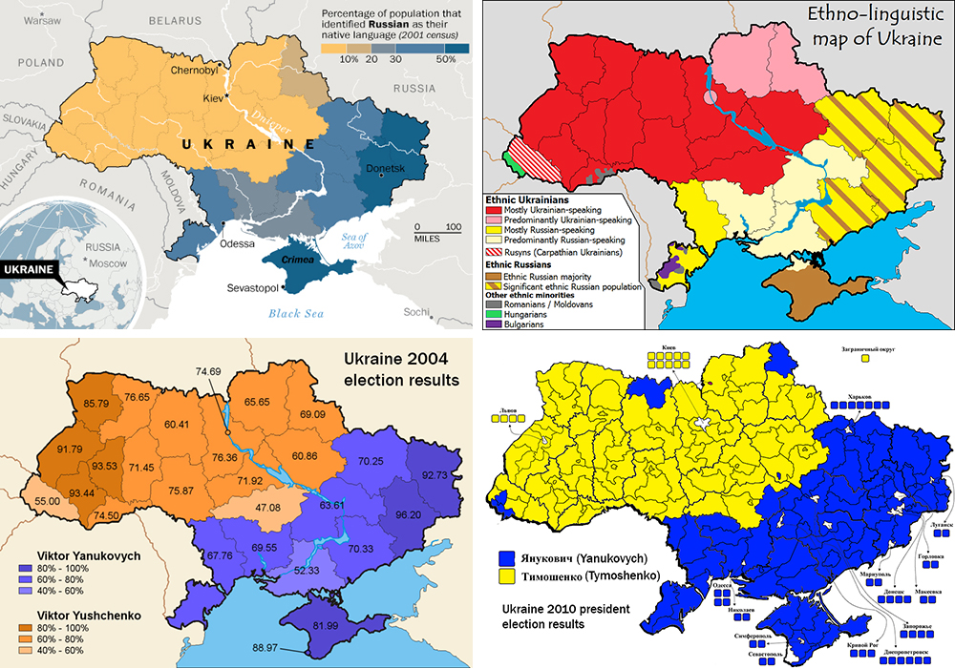

**On 28 February** unidentified gunmen in combat uniforms appear outside Simferopol International Airport and a military airfield in Sevastopol, sparking fears of Russian military intervention. The Ukrainian government accuses Russia of aggression. The United Nations Security Council holds an emergency closed-door session to discuss the situation in the Crimea. The United States also warns Russia of militarily intervening in the Ukraine. Moscow states that the military movements in the Crimea are in line with previous agreements to protect its fleet position in the Black Sea. The same day, Mr Yanukovych, now in Russia, appears at his first news conference and insists that he remains President. He also says that he opposes any military intervention or division of the Ukraine.

Prospects for a single pro-EU candidate at the proposed 25 May presidential election vanish, when contender Vitali Klitschko says Yulia Tymoshenko has told him that she wants to run too. Ukraine’s central bank limits daily foreign currency cash withdrawals to the equivalent of 15,000 hryvnia (approx. 1,000€).

**On 1 March**, as the situation worsens in the Crimea, local leaders ask for Russian President Vladimir Putin’s help. The Russian upper house of the parliament approves a request by Putin to use military power in Ukraine. The following day, 2 March, a convoy of hundreds of Russian troops heads towards the regional capital of the Ukraine's Crimea region, a day after Russia’s forces took over the strategic Black Sea peninsula without firing a shot.

**CURRENT SITUATION**

At its 7124th meeting on Saturday, 1 March, the Security Council urged for an immediate de-escalation of the situation. Similarly Secretary General Ban Ki-moon stated that dialogue must be the only tool in ending this crisis. He also requested President Putin to urgently engage in direct dialogue with the authorities in Kiev.

Ukraine’s government approved to put its army on full combat alert after Russia approved the deployment of its troops in order to “ensure the security and territorial integrity of Ukraine”. According to the Ukrainian Defence Minister some 6,000 extra Russian troops and 30 additional armoured vehicles are now in Crimea. Ukraine's armed forces are now in a state of full combat readiness to protect key energy and nuclear sites, reserves are to be mobilised and trained and emergency headquarters are to be set up officials say.

Likewise, US President Barack Obama articulated by sending troops to the Ukraine that President Putin that Russia has broken international law. Mr Putin stressed that in case of any further spread of violence to Eastern Ukraine and the Crimea, Russia retains the right to protect its interests and the Russian-speaking population of those areas.

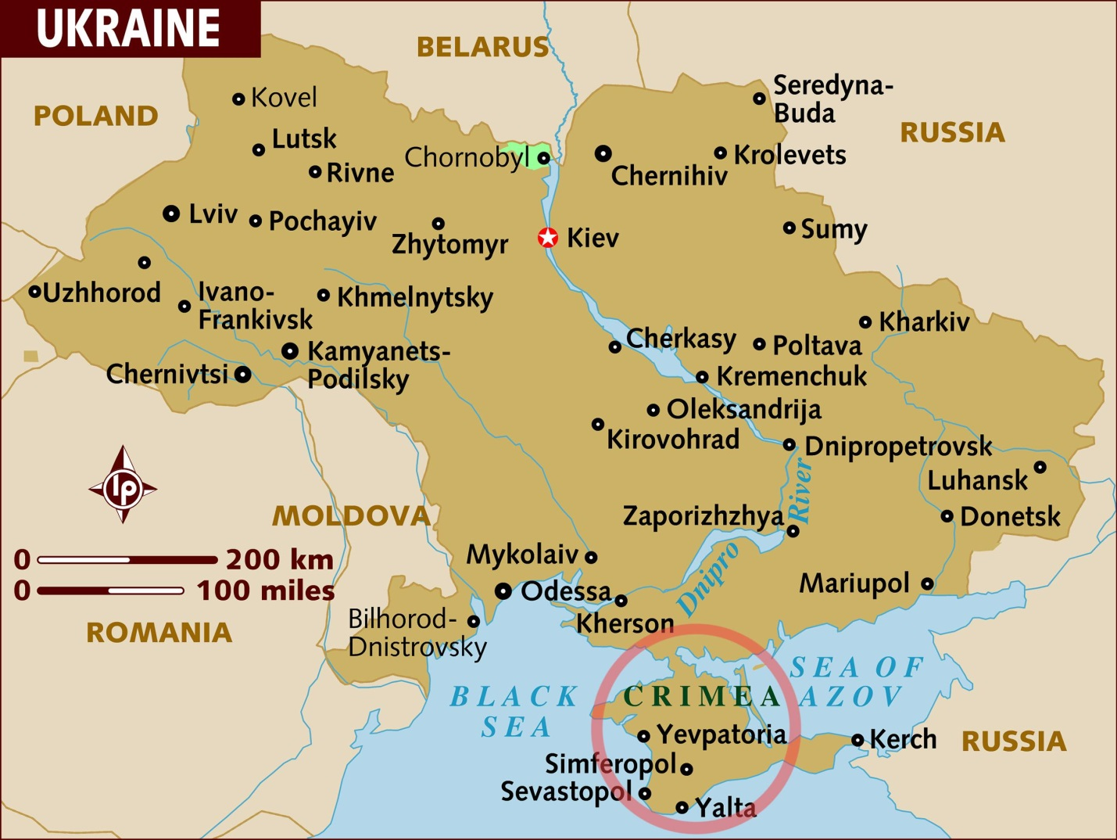

NATO held an emergency meeting on 2 March to discuss the escalating conflict in the Crimea when the organization’s Secretary General Anders Fogh Rasmussen stated that Russia was threatening peace and security in Europe. Mr Rasmussen also called on Russia to do what it can to diminish tensions existing in the region.

In a statement, PM Yatsenyuk said: “This is actually a declaration of war to my country. We urge Putin to pull back his troops from this country and honour bilateral agreements. If he wants to be the president who started the war between two neighbouring and friendly countries, he has reached his target within a few inches."

In a joint statement the leaders of the G7 countries (Britain, Canada, France, Germany, Italy, Japan, the United States) and the presidents of the European Council and European Commission said they joined together to "condemn the Russian Federation's clear violation of the sovereignty and territorial integrity of Ukraine, in contravention of Russia's obligations under the UN Charter and its 1997 basing agreement with the Ukraine." They also decided for the time being to suspend the preparation of the scheduled G-8 Summit in Sochi in June.

**FURTHER DEVELOPMENT**

Ukraine has called for the immediate dispatch of an international fact-finding mission to the Ukraine and the Crimea, as well as assistance in protecting nuclear facilities. It is inviting the OSCE, the EU and others to hold meetings in the Ukraine. It is also setting up a parliamentary negotiation group to reach out to Russian MPs.

**International Involvement**

China

On the one hand, China has long opposed interference in other states’ affairs. Beijing has a difficult time justifying Moscow’s interference in Ukraine, but China also defines the imposition of international sanctions as a form of interference and in principle opposes these, except in very limited cases, such as on Iran and North Korea.

The Chinese leadership, while up until now very sparse in words, now is publicly denouncing the western criticism of Russia and is of the opinion that the western countries are still lingering in a Cold War-like mentality and that this would continuously lead to unnecessary and avoidable confrontations with the Russian Federation.

The People’s Republic calls upon the Western countries to let go of such an out-dated way of thinking and instead further close cooperation with Moscow.

This is likely to increase their cohesiveness. China and Russia are closer to each other on the issues of the Syria conflict and Iran’s nuclear weapons development than to the Western parties, and they are likely to find it comfortable TO GETeven closer to shape the outcomes more to their liking.

France

Aside from France’s involvement in the Crimean war (October 1853 – February 1856), France assumed a rather passive political stance on the issue. Commercial relations between France

Ukraine are strong and established. In 2011 France was the 7th largest foreign investor in the Ukraine with more than 300 French enterprises setting up businesses there. In 2012, French exports to the Ukraine were valued just above 1 billion Euros. In the same year Ukrainian exports to France were reported to be equivalent to 539 million Euros.

France’ involvement in the current crisis on the Crimean peninsula can also be characterized as cautious. While the French – alongside the USA, Canada, United Kingdom, Germany, Italy, and Japan – vouched to suspend their attendance at the G8 summit in Sochi in June of this year because of actions taken by the Russian Federation, they still see their role as one of a mediator.

On February 20th the French foreign minister, together with his colleagues from Poland and Germany, brokered an agreement with the now ousted Ukrainian President Yanukovych that would allow for unified government that would leave Mr. Yanukovych in place as president until new elections would be held in December.

Russia

Russia and the Ukraine share a common history, which dates back to the 9th -12th centuries, when the Kievan Rus’, a loose federation of East Slavic tribes in Europe, was formed. Today a significant minority of the population of Ukraine are Russians or use Russian as their first language. Russian influence is particularly strong in the industrialised East, as well as in the Crimea, the autonomous republic on the Black Sea, which was part of Russia until 1954. The Russian Black Sea Fleet is based in the Crimean city of Sevastopol. Under the terms of the lease, the Russian fleet can be stationed there until 2042. However, any movement of Russian troops outside the base must be authorised by the Ukrainian government. The treaty allows for the maintenance of 25,000 officers and sailors, 161 aircraft and 388 warships and other vessels.

The Crimea is also the homeland of the Crimean Tatars whom Stalin accused of collaborating with the Nazis and deported to Central Asia in 1944. More than 250,000 have returned since the late 1980s. Under the current situation, Russia sees its taken measures as completely appropriate. Arguing that there’s a threat of violence coming from ultra-nationalists, Russia sees a threat to the lives and health of the Russian citizens and the many compatriots who are currently on Ukrainian territory. In the case of any further spread of violence to Eastern Ukraine and the Crimea, Russia therefore retains the right to protect its interests and the Russian-speaking population of those areas as it claims to be responsible for the safety of ethnic Russians in the region.

The United Kingdom

The United Kingdom has been a strong proponent for closer ties between the Ukraine and the EU in the past. Consequently it welcomed the new pro-European government and pledged economic support. The UK considers Russia’s involvement in the Crimea the “biggest crisis in Europe in the 21st century”, calling it an act of aggression and contrary to the UN Charter – thus a violation of international law. It urged the Russian government to respect the territorial integrity of the Ukraine by withdrawing their troops and to take up direct consultations with the new Ukrainian government. The United Kingdom, following the United States, threatened that a further military involvement of Russia will have ‘costs’ on their part.

The United States of America

The United States has showed that it supports the newly formed Ukrainian government and called upon the international community to support the people of Ukraine on their path.

Nevertheless, the United States urged that the new government has to be inclusive and representative and that minorities’ rights in the Ukraine, in particular of the Russian minority, have to be respected.

The United States also reaffirmed its past commitment for the unity, territorial integrity and sovereignty of Ukraine. Thus Russia’s troop deployment in the Crimea has been strongly criticized, declaring that it will have ‘costs’. In particular, the United States threatened that in case should Russia fail to withdraw their troops, economic sanctions will ensue, such as the exclusion from the G8, claiming that eventually Russia’s actions could lead to its ‘political and economic isolation’. In order to solve the crisis, the United States have proposed the deployment of international observers and an independent, international mediation mission.

Consequences of the crisis

One clear outcome of the situation regarding the Ukraine is the economic problems it would bring to Europe. International Monetary Fund chief Christine Lagarde warned in a German newspaper interview Monday that the Ukraine crisis could have "severe" economic consequences for other countries.

Lagarde also told the Handelsblatt business daily that a 17-billion-dollar aid package granted to Ukraine by the IMF would not be enough.

"The crisis in Ukraine is a danger which is very difficult to gauge (and) whose contagion risk for other countries can barely be predicted," she said.

"All the same, it can have severe economic consequences."

Lagarde will meet German Chancellor Angela Merkel in Berlin on Tuesday for annual talks, alongside the heads of the OECD, World Bank, World Trade Organisation and International Labour Organisation, on the global economic situation.

When asked where the biggest dangers lay, the IMF chief pointed to the turmoil in Ukraine having an impact on international trade, foreign direct investment, international capital flows and Europe's energy supply.

"Ukraine needs much more than 17 billion dollars. For example, bilateral help from abroad and financial help from other international financial institutions," Lagarde said, adding that the international community had no choice.

"We can't simply say the situation is too precarious, therefore we're not giving money at the moment."

There are several other examples of other such secessionist movements in Europe, each wth their own outcomes affecting Europe politically and economically. It is strongly recommended that you quickly read through this article regarding such separatist movements that can be found here: <http://www.nationalreview.com/article/376663/europes-secessionist-movements-john-fund>

**Key Issues**

• How should the Security Council react to the deployment of Russian forces in

the Crimean region?

• Should the Security Council authorize an international mediation team to be sent to the Crimean region?

• How can sovereignty and integrity of the Ukraine be preserved and at the same time the interests of ethnic Russians be protected?

• How can the new Ukrainian government and the International Community protect minority rights (such as those of the Tartars)?

• How can the International Community support the Institution Building process of the new Ukrainian government

**Involvement of supranational bodies**

Council of Europe PACE's Standing Committee expressed its full support for the "territorial integrity and national unity of Ukraine" on 7 March.

European Union – On 1 March, High Representative of the Union for Foreign Affairs and Security Policy Catherine Ashton stated that the E.U. "deplores" what it called Russia's decision to use military action in Ukraine, describing it as an "unwarranted escalation of tensions."

She called on "all sides to decrease the tensions immediately through dialogue, in full respect of Ukrainian and international law." She added that: "The unity, sovereignty and territorial integrity of Ukraine must be respected at all times and by all sides. Any violation of these principles is unacceptable. More than ever, restraint and sense of responsibility are needed."

The President of the European Parliament, Martin Schulz said that who could have imagined “that war could become a genuine possibility in a country which shares a border with the European Union?”

The Organization for Economic Cooperation and Development suspended the accession process of Russia on 13 March and began strengthening ties with Ukraine.

The Organization of Islamic Cooperation expressed concern about the "security and well-being" of the Muslim Crimean Tatar community. "Any recurrence of the past suffering of the Crimean Tatars who were expelled from their homeland in Crimea in the 20th Century should not be allowed. It is of the utmost importance for the OIC that the right of citizenship, lives, religious and cultural heritage and property should be safeguarded. It is the firm belief of the OIC that in the 21th century, constructive dialogue, peaceful and good neighborly relations should be the norm for the members of the international community."

United Nations – On 1 March, while members of the UN Security Council were meeting in an emergency closed-door session, a spokesman for UN Secretary-General Ban Ki-moon delivered a statement saying that he was "gravely concerned about the deterioration of the situation" in Ukraine and planned to speak shortly with Putin. It also called for "full respect for and preservation of the independence, sovereignty and territorial integrity of Ukraine" and demanded "immediate restoration of calm and direct dialogue between all concerned." The Security Council itself expressed support [dubious – discuss] for the unity, territorial integrity and sovereignty of Ukraine. It agreed that it was important that all political actors in Ukraine to "exercise maximum restraint" and called for an "inclusive dialogue recognizing the diversity of Ukrainian society.

Resolutions

<http://www.un.org/News/Press/docs/2014/sc11314.doc.htm>

<http://www.un.org/News/Press/docs/2014/ga11493.doc.htm>

Bibliography

<http://www.bbc.com/news/world-middle-east-26248275>

<http://www.theguardian.com/world/2013/nov/21/ukraine-suspends-preparations-eu-trade-pact>

<http://www.aljazeera.com/news/europe/2014/03/timeline-ukraine-political-crisis-201431143722854652.html>

<http://www.bbc.com/news/world-europe-26405082>

<http://www.bbc.com/news/world-europe-26367786>

<http://www.bbc.com/news/world-europe-26407604>

<http://www.bbc.com/news/world-europe-18287223>

<http://www.un.org/apps/news/story.asp?NewsID=48161>

<http://www.un.org/apps/news/story.asp?NewsID=48049#.U7RWaPmSztg>

<http://edition.cnn.com/2014/04/13/world/europe/ukraine-crisis/>

**Topic II: The promotion and strengthening of the rule of law in the maintenance of international peace and security**

**Introduction**

The assurance of international peace and security in a changing world is the core aim and purpose of the United Nations. However there have been a lot of complications and in many ways failures over the years in maintaining this international peace and security due to the poor implementation of international rules and regulations. However in recent years due to the vast amount of developments in technological weaponry and increasing possession of illicit weaponry by hostile and rebel groups tensions have risen and stakes are higher than ever.

*The sudden expansion of illicit weaponry and narcotics*

The use of explosive weapons against civilians, and the porous borders which permit the illicit flow of weapons, narcotics and people all point towards a stronger oppositional force growing more and more capable of causing destructive harm. These dangerous factors combined with technological boosts and innovation, have strengthened the hand of armed groups and criminals as well as extremist elements. This newfound strength enhances their power of causing mass destruction through asymmetric, planned and coordinated tactics. These groups start to become well-equipped and well-resourced with unprecedented reaches on different locations. Therefore, this un-veiled threat of growing rebel and hostile groups needs to be vanquished as quickly as can be, otherwise, havoc will definitely ensue.

*The handling of conflict and post-conflict situations*

Another crucial factor that affects the maintenance of peace and security are conflict and post-conflict situations. Conflicts, if controlled or managed constructively, do not lead to violence. Some conflicts are mutually satisfactory while others end up frustrating one or all parties. Some conflicts are country-wide (Rwanda), and others are localized in specific parts of a country (Sudan). Their origins, often multifaceted, range from ethnic and economic inequalities, social exclusion of sectors of the population, social injustice, competition for scarce resources, poverty, lack of democracy, and political tensions. The conflicts in the Sudan, Burundi, and Rwanda are, in large measure, the result of historical discrepancies between the ethnic or tribal components of the population. This sparks riots that range for a long period. On the other hand, post-conflict is a conflict situation in which open warfare has come to an end. Such situations remain tense for years or decades and can easily relapse into large-scale violence. They relapse as easily as they start. Therefore, they need to be handled with care and precaution. In post-conflict areas, there is an absence of war, but not essentially real peace. Prolonged conflict can lead to terrible human loss and physical devastation; it can also lead to the breakdown of the systems and institutions that make a stable society work and these are the very systems that need to be revived.

**Background**

***Cambodian Genocide***

The past century has unfortunately seen numerous genocides and civil wars. These events have led to a weak maintenance of peace and security and a poor attempt at promoting the idea of tranquility. Between the years of 1975-1979, a violent genocide ensued in Cambodia under the leadership of Pol Pot. Within a few days of overthrowing the government, the Khmer Rouge embarked on a detailed mission: they ruthlessly imposed an extremist programmer to reconstruct and rebuild Cambodia, as a nation (now under its Khmer name Kampuchea) based on the communist mode of Chairman Mao’s China. They strongly believed that the population must be made to work as labourers in one huge federation of collective farms. Anyone opposing this movement was to be eliminated.

Under the imminent threat of death, civilians were forced to leave towns and cities. The weak were driven out as well, regardless of their physical capacities. No-one was spared. People who refused to leave were killed therefore civilians that did not depart fast enough or who refused to obey orders were killed.

All political and civil rights were abolished and children were forcefully separated from their parents at labour camps. Factories and universities were shut down and professional individuals were completely halted of their work. Most were murdered. Religion was completely prohibited and Buddhist monks were killed and their temples destroyed. One Khmer slogan ran ‘To spare you is no profit; to destroy you is no loss.’

People who escaped the killings became unpaid labourers, working on minimum rations for impossibly long hours. They slept and ate in uncomfortable locations and stayed as far away from their old houses as possible. Their personal relations where cut off and they expressed hardly any affection. People soon became weak and overcome with fatigue and starvation. They started to fall ill. There was no treatment except death.

Minority groups were targeted during this genocide such as Chinese, Vietnamese and Thai. Half the Cham Muslim population was murdered and 8,000 Christians. This report explains the trying times civilians faced and how the situation escalated in terms of power and causalities as a result of poor enforcement of peace and security. Ammunition was easily acquired by the Khmer which resulted in their thriving movement. Civilian deaths during this period, from executions, disease, exhaustion and starvation, have been estimated as well over 2 million. 2 million lives could have been saved if the curbing of illicit weaponry and the handling of conflict situations would have been more efficient. Succeeding in doing so would have definitely promoted the rule of law as matters were dealt with calmly and tactfully.

*The Sierra-Leone Civil War*

The next instance regards a Civil War which could have been prevented had dramatic steps towards security been implemented. Sierra Leone has seen serious and grotesque human rights violations since 1991 when the civil war erupted. Over 50,000 people have been killed to date, with over one million people having been displaced. President Momoh had raised suspicions of not being serious regarding his promise on political reform. The brutal civil war that was going on in Liberia, the immediate neighbor of Sierra Leone played a role in the outbreak in the nation itself. Charles Taylor, the leader of The National Patriotic Front of Liberia, apparently helped the Revolutionary United Front (RUF) under the command of former Sierra Leonean army corporal Foday Saybana Sankoh. ON the 29 April, 1992, Capt. Valentine Strasser launched a military coup which exiled President Momoh in Guinea and made Strasser the Chairman of the country. In 2001, UN forces moved into rebel areas and began to disarm rebel soldiers. By January 2002, the eleven-year civil war was declared over.

*United Nations Peace-Keeping forces*

The United Nations have taken leaps to ensure the establishment of Peace as of today’s generation. The United Nations has acted through a variety of mechanisms, including 15 [peacekeeping operations](http://www.un.org/en/peacekeeping/operations/current.shtml), 14 [field-based special political missions](http://www.un.org/wcm/content/site/undpa/main/about/field_operations), 10 [special envoys and advisers](http://www.un.org/sg/srsg/africa.shtm), and many United Nations country teams around the world. The [United Nations Mission in South Sudan](http://unmiss.unmissions.org/) continued to support the protection of civilians amid escalating intercommunal violence in Jonglei State. With the support of the [United Nations Interim Security Force for Abyei](http://www.un.org/en/peacekeeping/missions/unisfa/), the operationalization of the Joint Border Verification and Monitoring Mechanism and the Safe Demilitarized Border Zone played a major role in improving relations between the Sudan and South Sudan. In Darfur, Sudan, evolved conflict dynamics allowed the [African Union-United Nations Hybrid Operation in Darfur (UNAMID)](http://unamid.unmissions.org/) to focus on areas with the highest security threats. Nevertheless, the intensification of violence in some parts of Darfur, including the targeting of UNAMID troops, has highlighted the need to increase the mission’s capacity to deter and address threats to civilians. Therefore though the past has faced turbulent times regarding peace and security, the Peace-Keeping force has continued to do all in its power to establish this view and has strongly projected the idea of continuing to do so.

**Current issues surrounding the topic**

*UN Mandate Enforcement-MONUSCO*

Most recently, on the 28th of March, the Security Council extended the mandate of the United Nations Organization Stabilization Mission in the Democratic Republic of Congo (MONUSCO) until 31 March, 2015. The Council decided that the renewed mandate would also include MONUSCO’s Intervention Brigade within the authorized troop ceiling of 19,815 military personnel, 760 military observers and staff officers, 391 police personnel and 1,050 formed police units. At the same time, the 15-member body noted the need for a clear exit strategy, including for MONUSCO’s Intervention Brigade, and decided that the Mission’s further reconfigurations and mandates should be based on the evolving situation and progress of the DRC.

The Council directed MONUSCO to enhance its interaction with the civilian population, and to ensure that any support it provided to the national security forces was in strict compliance with the United Nations policy on human rights. The council assigned MONUSCO the mission of reducing the threat posed by Congolese and foreign armed groups, as well as violence against civilians, including sexual and gender-based violence which should be eradicated immediately.

The Council informed MONUSCO to provide civilian protection, support political processes, and neutralize armed groups.

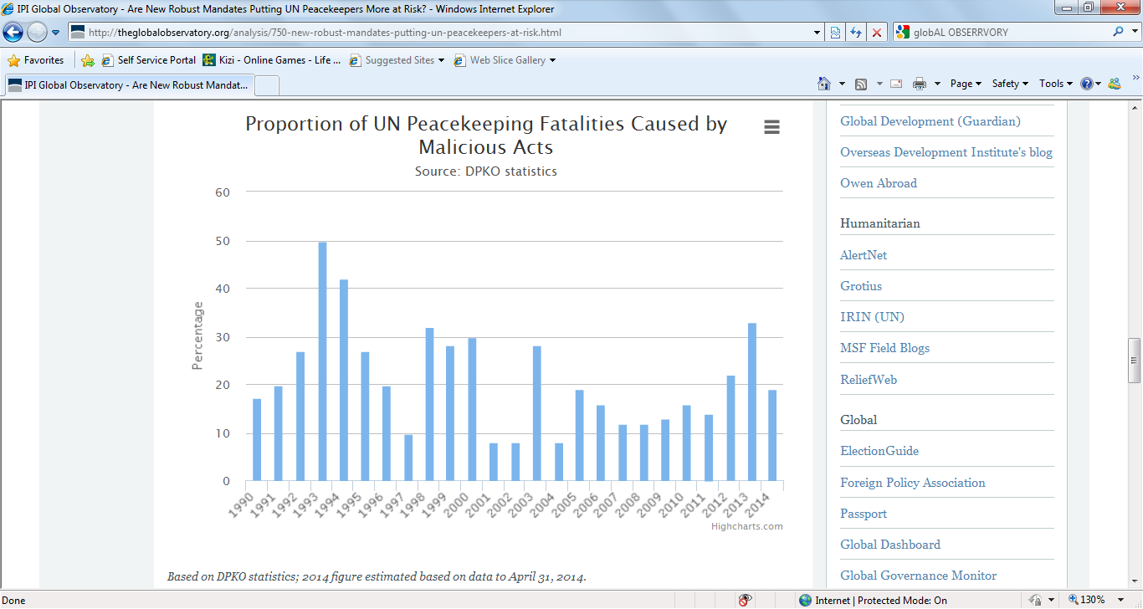

The Security Council issued a statement about the rule of law and what measures need to be done in order for it to be effectively executed:

A new three-tier system to strengthen the Organization’s ability to deliver activities related to the rule of law at the field level, at the Headquarters (Operational support) level and at the strategic level. At the field level, the power of United Nations field leadership has been enhanced. Leaders in the field are now responsible and accountable for guiding and overseeing United Nations rule of law strategies, resolving political obstacles and coordinating United Nations country support on the rule of law. While responsibility for programmer implementation is left firmly in the hands of the different United Nations entities, however, in order to maximize the benefits arising from their comparative advantage, these entities are also required to cooperate with senior field leadership.

**Proposed Solution**

*Deployable team*

The Security Council emphasized the idea of bringing forth a deployable team of Rule of Law experts to assist national authorities in the establishment of tranquility. This idea furthers the cause of serenity as it tackles key areas of instability in a nation. The deployable team could easily identify the hurdles that would occur in a country if threatened by rebel armed groups.

*International Court of Justice and its involvement*

The Security Council yet again, brought up the essence of the ICJ and their crucial role in the peaceful settlement of disputes. The council also discussed the idea of strengthening the court’s relationship with the Security Council, thus allowing for better ties in the future, when required.

*Department of Peacekeeping Operations (DPKO)*

Lastly, the final solution which could resolve this world wide threat is the DPKO. The council accentuated the pivotal role DPKO would have in eliminating threats and protecting civilians during trying times. The council also specified the DPKO’s affiliation with the Rule of Law Coordination and Resource group which would provide all the necessary equipment for civilian protection. Though these organizations face challenges when it comes to recruiting personnel, the council has accepted to help these affiliated committees.

**The Conclusion**

Efforts have been taken to ensure the strengthening of the rule of law as seen by the DPKO, the ICJ and other committees. The effects of Genocides and Civil Wars have been seen and in order to prevent more from occurring in the future, effective, solidified steps need to be dispatched in order to ascertain a brighter future for the nations across the World and more specifically, for the civilians who inch closer and closer to death due to catastrophic vicious cycles.

**Bibliography**

<http://www.govguide.org/conflict/context/defining-conflict>

<http://www.un.org,sg/speeches/reports/68/report-peace.shtml>

<http://www.ppu.org.uk/genocide/case.html>

<http://web.undp.org/evaluation/documents/thematic/conflict/sierraleone.pdf>

<http://www.bbc.co.uk/news/world-africa-14094419>

<http://www.securitycouncil-report.org/month-forecast/2014-07>

<http://globalobserver.org/analysis.html>

<http://www.un.org/en/sc/reportoire.pdf>

**Topic III: United Nations to use unmanned aerial vehicles in Democratic Republic of the Congo**

**Introduction**

Over the past few years, there has been much discussion of Unmanned Aerial Vehicles (UAVs) and how they have reshaped global military strategies. However discussion on the use of unarmed UAV’s and how they could reshape the world’s strategy for peace have been very limited. The United Nations Security Council, with support from the United States, approved the use of unarmed Unmanned Aerial Vehicles (UAVs) by the United Nations Organization Stabilization Mission in the Democratic Republic of the Congo or MONUSCO (until 2010 known as United Nations Mission in the Democratic Republic of Congo or MONUC)

MONUSCO will utilize the unarmed UAVs for four basic functions:

* To augment situational awareness on the ground and, consequently, the ability to protect civilians and peacekeeping troops;
* To monitor armed groups and trafficking of arms;
* To assess the movements of displaced refugees in order to better address their needs;
* To evaluate environmental challenges, including assessing damages from natural disasters.

**MONUSCO’s Impact in DRC**

* Since 2007, MONUSCO has helped to demobilize over 33,000 child soldiers and reintegrate them into society.
* Since 2002, 14,850 foreign rebel combatants have been repatriated back to their home countries.
* MONUSCO has also improved the DRC’s national police forces by training more than 1,800 new police officers, including 97 women.
* MONUSCO has been one of the most innovative peacekeeping operations to develop strategies to protect civilians including the distribution of high-frequency solar-powered radios and construction of cell phone towers, to help communities in the region report on the movement and activities of rebel groups. This and other new strategies are now serving as good practices that are being adopted in other missions in Sudan, Liberia, Ivory Coast, and Lebanon.

Furthermore, between November 2012 and February 2013, MONUSCO removed 13,649 unexploded ordnance and 98,274 small arms ammunition. It also educated 25,588 people on mine risks.

**History of the Use of UAVs in the DRC**

In 2006, the United Nations Organization Mission in the DRC (MONUC) was supported for a time by a European Force and Belgian troops who possessed surveillance drones. One of the drones was shot down while another crashed, injuring and killing some civilians in Kinshasa and ending that particular effort to employ drones in the DRC conflict. In May 2010, the name and mandate of MONUC were changed to MONUSCO with two major priorities, namely: the protection of civilians as well as stabilization and peace consolidation in the DRC. MONUSCO was authorized to use all necessary means to carry out its mandate, which it failed to deliver on as numerous rebel movements in eastern DRC continued to prey on civilians. Often, rebels and militias did not respect MONUSCO personnel.

After the town of Goma fell to the rebels in November 2012, the International Conference on the Great Lakes Region (ICGLR) called for the establishment of a “Neutral Force” to be deployed to neutralize all the negative forces (both foreign and local) operating in the region. In February 2013, the Peace, Security and Cooperation Framework for the DRC and the Region was signed and among other things called for “strengthening support to the government [of the DRC] to enable it to address security challenges and extend State authority. Subsequently, the Security Council formally gave MONUSCO the go-ahead to contract UAVs for the purposes of observing and reporting on flows of military personnel, arms or related materiel across the eastern border of the DRC. The UN Office of Central Support Services, Procurement Division released a bid for the provision of one unmanned aerial system (UAS) to be used by MONUSCO for three years. The tender was won by an Italian company called Selex ES, and the deployment date was in December 2013.

**Concerns over the Use of UAVs by the UN**

First, the use of UAVs in peacekeeping missions raises the question of ownership of the large amounts of data collected and stored. The UN, it has been observed, needs to address the following questions if it is to integrate UAVs in its peacekeeping missions;

* What should be done with the information gathered by the UN UAVs?
* Who could and should have access to live video streams?
* Who could and should have access to recorded streams?

To protect the integrity of UN peacekeeping, Karlsrud and Rosen have counseled that there must be effective regulation to ensure that any information collected with UAVs is the property of the UN alone. Otherwise, they warn, any leaks of information collected in this manner will rapidly destroy the legitimacy of UN UAVs.

The other concern raised by the use of UAVs in peacekeeping missions, in particular in the DRC, relates to the law. The first legal question is;

Is it legal for *non-military personnel* to operate a drone in a combat zone?

UAVs in DRC are being operated by civilian contractors who are not UN peacekeepers, which raises issues under the customary law principle of distinction. The principle denotes that parties to an armed conflict must distinguish between the civilian population and combatants, and between civilian objects and military objectives. The significance of the principle lies in the fact that it is essential to define who and what may be attacked. The overarching aim is to spare civilians and the civilian population from hostilities and their effects. Civilians not incorporated into the armed forces who unlawfully take a direct part in hostilities lose their protection against attacks, as long as they directly participate. The civilian operators of UAVs are deemed to be directly participating in hostilities (i.e., legitimate combatants) and thus open to attack by enemy forces. Is the UN ready to take responsibility for these civilian contractors?

**Need for UAVs in the Democratic Republic of the Congo**

The eastern provinces of North and South Kivu of the DRC are huge expanses with very few roads. The lack of infrastructure and dense forests combined makes it very difficult and dangerous for the UN to patrol and secure the country. In addition to these significant operational difficulties, UN peacekeepers also have to contend with more than a dozen armed groups that operate in the region.

Due to these difficult conditions and in an attempt to better monitor armed groups, the UN has had to operate helicopters and planes for surveillance and transport, but this can be costly. In addition, the UN has lost 55 staff members over the years, including a devastating airplane crash in 2011 that claimed the lives of 24 UN employees and a helicopter crash in the eastern province of South Kivu, killing four Russian nationals.

While no peacekeeping operation can be expected to protect all of the people in their areas of operation all of the time UAVs are intended to substantially increase prevention and response by increasing visibility and decreasing reaction time.

**How the Use of Unarmed UAVs by the UN Will Function**

The UN is aware of the drones’ reputation for targeted killing especially outside of the United States but has said that it sees the use of drones for surveillance as necessary and that in effect the drones are not more than objects to enable cameras to survey the area, and improve the safety of its troops in the Congo. The drones allow the UN to follow the movements of armed groups, populations and the arms that are being carried by people on the ground all from visuals being made by the drones’ cameras from up to 3km above ground. This inevitably allows the UN to guide its troops into safety and to accurately warn of imminent danger or settlements that are in danger.

The UAVs that the UN Department of Peacekeeping Operations plans to deploy are not equipped with weapons. Rather, they are essentially flying cameras. These vehicles can fly up to 12 hours at a time with a range of 150 miles. The initial system will include three unarmed UAVs, which would be deployed in North Kivu at night for around 10-12 hours at a time. The unarmed UAVs will carry day/night cameras with electro-optical and infrared thermal technology, would be able to operate from a height of 18,000 feet, and can capture and relay still and video images. The images captured by the UAVs will be relayed to a command and control base, which will in turn store the data, providing both near real-time analysis and identifying trends over time. The unarmed UAV system will not be operational, however, without the qualified personnel.

The UN will only seek, collect, and use this information that is relevant to its Security Council mandate and/or its ability to efficiently and effectively carry out its mandated tasks. The UN will share operationally relevant information with the host country if it is relevant to MONUSCO’s Security Council mandate.

**Benefits of Unarmed UAVs in DRC**

Due to the difficult conditions in eastern DRC, it can take peacekeepers five to six hours to patrol a 10 to 15 mile radius and, the troops in this region are night blind because of the limitations of their current resources and must stop patrolling at sunset. Armed groups in the region realize this and travel mostly at night. The UN’s UAVs will be conducting nighttime surveillance. This can help improve the UN’s early warning system by providing peacekeepers with more accurate and timely information on the movements of rebel groups.

In addition to enhancing its early warning capabilities, the use of UAVs could benefit MONUSCO’s activities in a number of other ways. For example:

* MONUSCO currently depends on helicopters and foot patrols for its surveillance activities. Adding UAVs will free up helicopter flying hours so they can be used for other critical tasks, such as deploying a quick reaction force in a crisis, extracting, medivacking, and supplying UN staff. This would allow UN peacekeepers to be deployed into more remote field locations to provide security and protect civilians.
* UAVs are more efficient and effective when it comes to surveillance activities than helicopters. In one month, an Unmanned Aerial System (UAS) can accomplish what it would take 15-19 helicopters to do. In the same timeframe, UAS can complete the same surveillance in 200-250 flying hours, compared to 600-700 helicopter flying hours.
* UAV’s may have a deterrent effect if armed groups know that the UN is watching their movement or hear them overhead.

**Conclusion**

The UN has contemplated UAV deployment in its peacekeeping missions for years. UAVs, the UN believes, are a modern response that can rapidly improve success and reaction rate of peacekeeping forces through surveillance. Whilst there are still lingering concerns in law on the use of UAVs, it appears their perceived deployment partly played a role in finally ending the M23 rebellion of the M23 group in eastern DRC. In the end, with the rapid changes in the world, especially developments in ICTs, the UN has to adapt by creating and maintaining structural and operational flexibility. The use of UAVs in UN peacekeeping missions is such an adaptation. These tools also stand to enhance MONUSCO’s surveillance capabilities and potentially minimize violence or even in some cases, deter it.

Still, as the pilot program in DRC opens the door for UN peacekeepers to better protect the civilians in the Kivu, who have lived in conflict for nearly twenty years, it is important to note that, while UAVs are a tool that UN peacekeepers can use to help create the conditions for peace, the onus for maintaining peace ultimately lies with the Congolese government and its people.

<http://www.iiss.org/en/publications/strategic%20comments/sections/2014-a6f5/drc-sets-precedents-for-un-forces-286f>

<http://www.un.org/apps/news/story.asp?NewsID=46650#.U7VV1JSSyKc>

<http://www.un.org/en/peacekeeping/articles/Transcript_USG_Ladsous_press_briefing_13_Dec_2013.pdf>

<http://www.securitycouncilreport.org/monthly-forecast/2013-02/democratic_republic_of_the_congo_1.php>

<http://mg.co.za/article/2013-12-03-un-to-start-using-surveillance-drones-in-drc>

<http://www.asil.org/insights/volume/18/issue/13/use-unmanned-aerial-vehicles-drones-united-nations-peacekeeping-case>

<http://www.foxnews.com/world/2014/03/01/un-using-drones-to-monitor-congo-border-fleet-to-grow-this-spring/>

<http://www.atlanticcouncil.org/publications/external/intelbrief-unmanned-peacekeeping-are-drones-the-new-blue-helmets>

<http://www.betterworldcampaign.org/assets/pdf/bwc-white-paper-the-uns-use-of-uavs-in-th-drc-may-2013.pdf>

<http://www.globalpolicy.org/component/content/article/181-congo/52554-un-uses-drones-for-surveillance-in-eastern-congo-.html>

<http://www.whatsinblue.org/2013/12/democratic-republic-of-the-congo-consultations.php>